**BITS F464 - Machine Learning**

Assignment Report

**Group Members**:

1. Abhishek Pandey – 2016A7PS0081H
2. Shubham Paliwal – 2015B1A70823H
3. Himanshu Badlani – 2015B3A70548H
4. Fisher Discriminant Algorithm

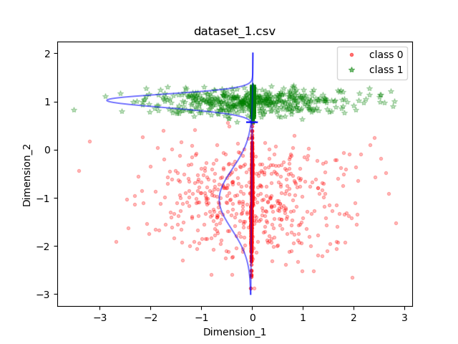

Weight vector: [0.0083803,0.99996488]

Intersection point: [0.00477187,0.56939512]

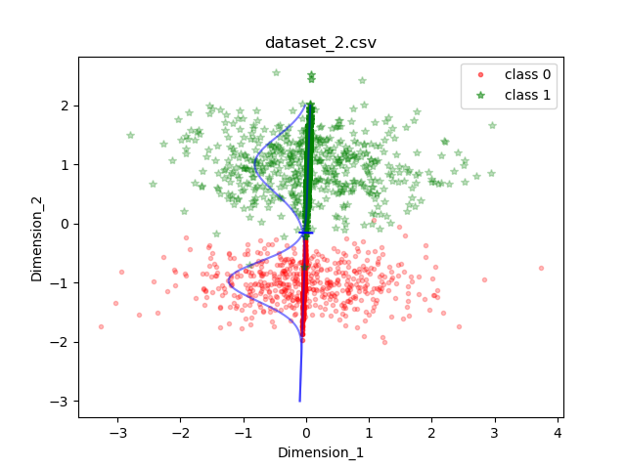

Weight vector: [0.03304637, 0.99945382]

Intersection point: [-0.00502539, -0.15198782]

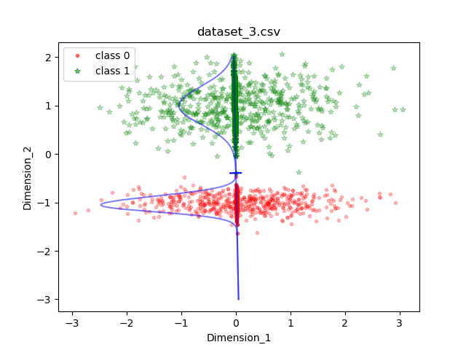

Weight vector: [-0.01760377, 0.99984504]

Intersection point: [0.0069185, -0.39295184]

Conclusion: Dataset 2 is not linearly separable, hence we didn’t get clear decision boundary for it.

1. Perceptron



Final separating vector: [427.0, -69.3583095, -808.0834166]



Final separating vector: [-29.0, 14.0284153, -162.855409]



Final separating vector: [-226.0, -96.404465, -906.1655146]

PERCEPTRON CONVERGENCE THEOREM: It states that if there is a weight vector w* such that f(w*p(q)) = t(q) for all q, then for any starting vector w, the perceptron learning rule will converge to a weight vector (not necessarily unique and not necessarily w*) that gives the correct response for all training patterns, and it will do so in a finite number of steps.

We observe that it did happen for all three data sets and hence the theorem held true for our case.

The final results of Perceptron may be affected by initial parameters and order of training samples leading to convergence taking different time to reach same result vector.. The order of training samples can matter if we are using stochastic gradient descent. In Fisher, neither of above matters and result is always same.